BÁO CÁO THỰC HÀNH
IT3280 – 147793 – THỰC HÀNH KIẾN TRÚC MÁY TÍNH
Tuần 12: CACHE MEMORY
Họ và tên | Lê Đồng Cảnh Phú
Mã số sinh viên | 20225755

Assignment 1: Running the Data Cache Simulator tool
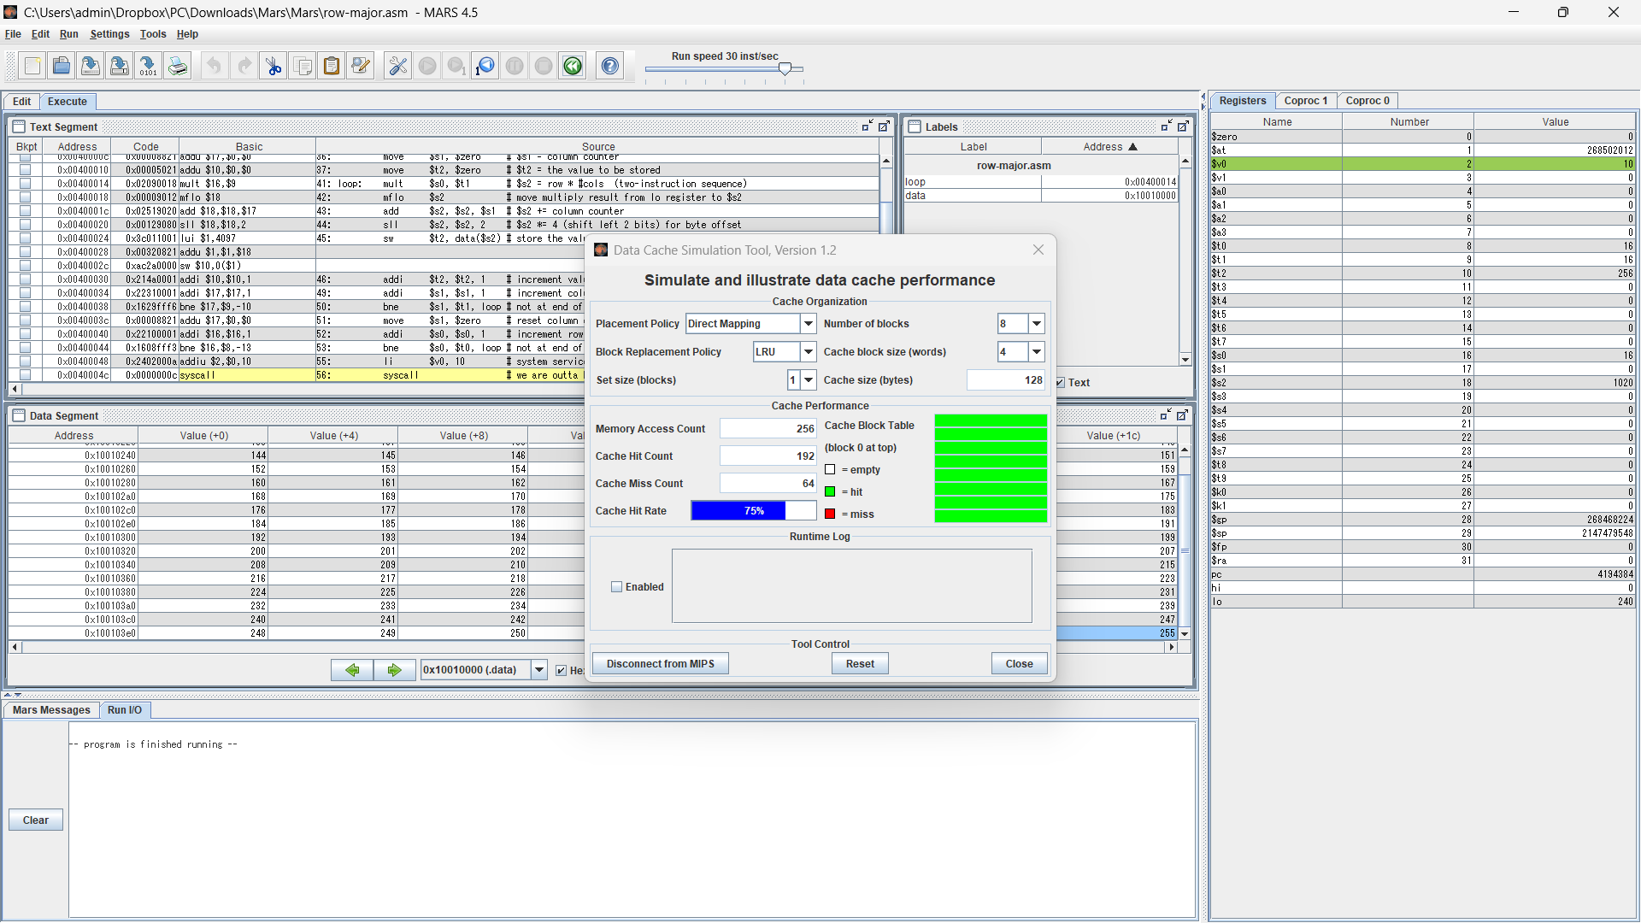
8. The final cache hit rate was 75%
9. The hit rate will be 87.5% if the block size is increased from 4 words to 8 words and 50% if the block size is decreased from 4 words to 2 words.
10. Verify
- Increased from 4 words to 8 words:
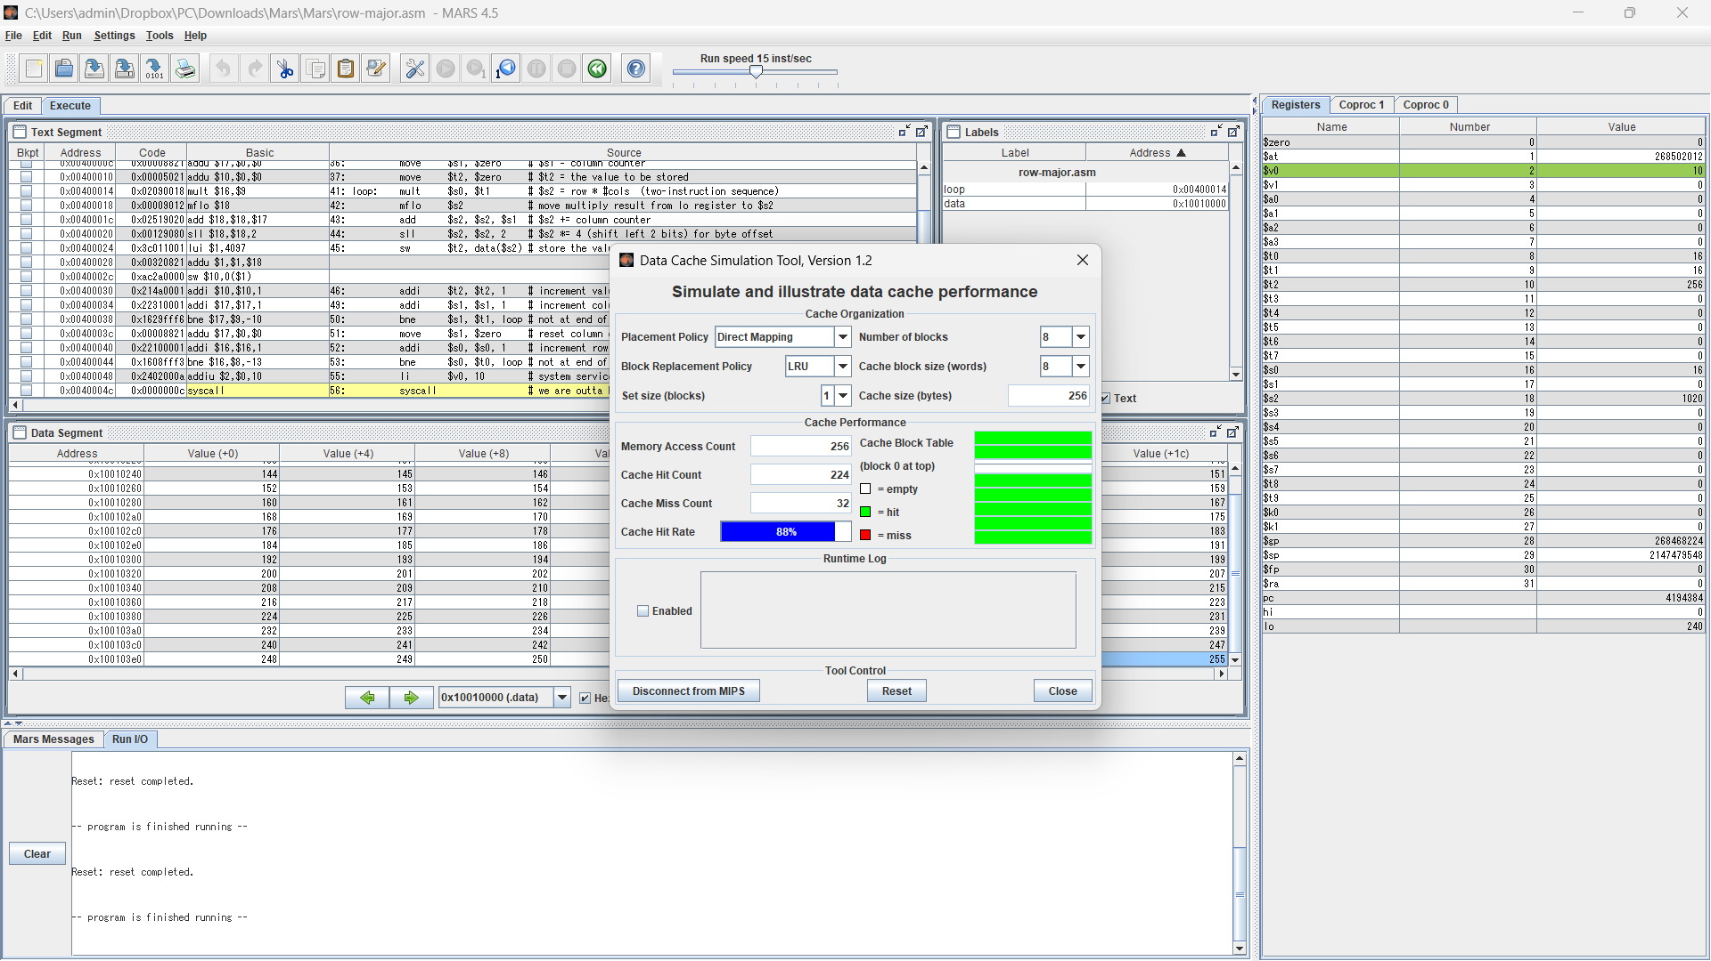
- Decreased from 4 words to 2 words:
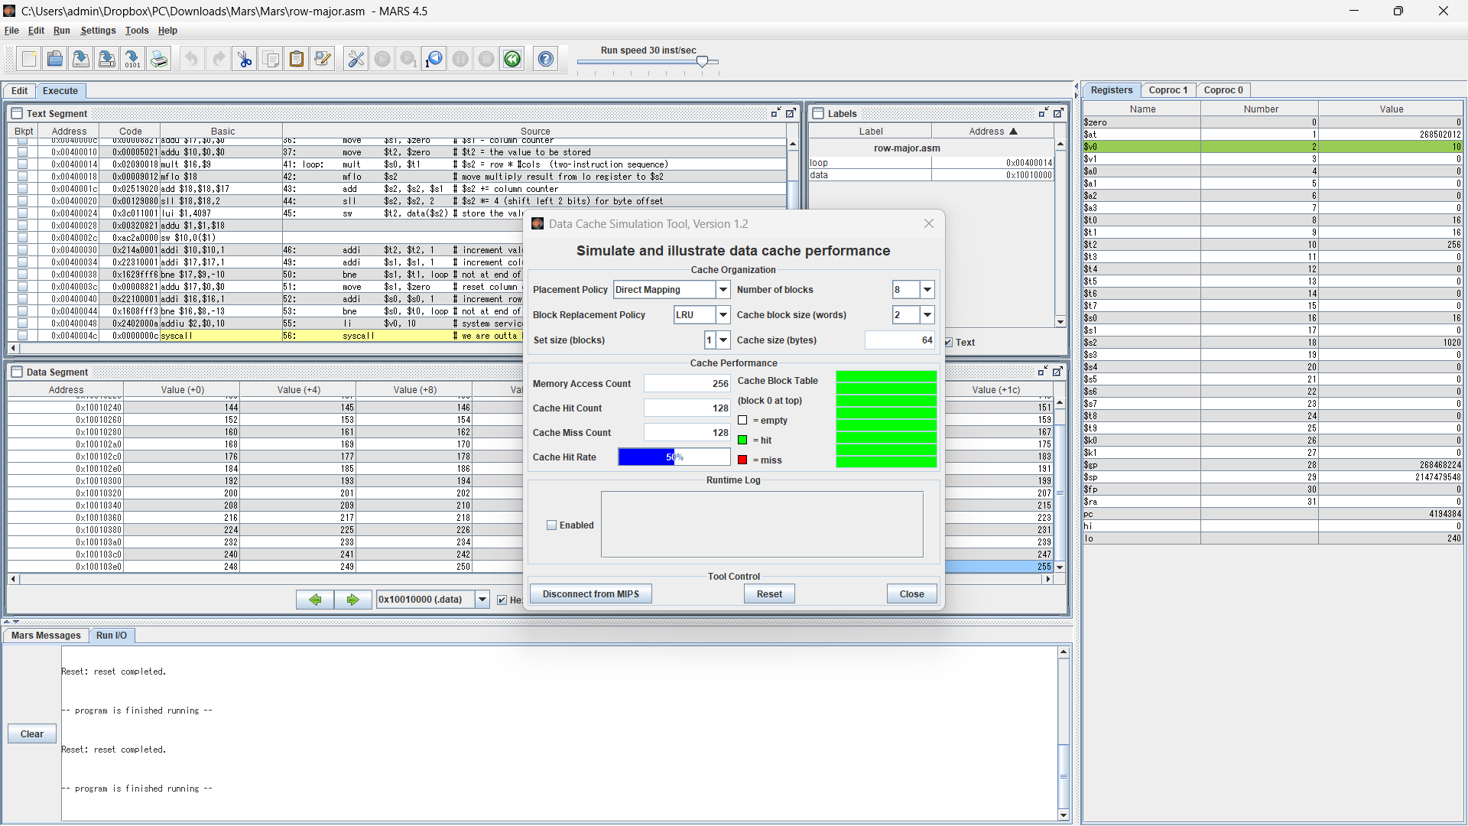
11.
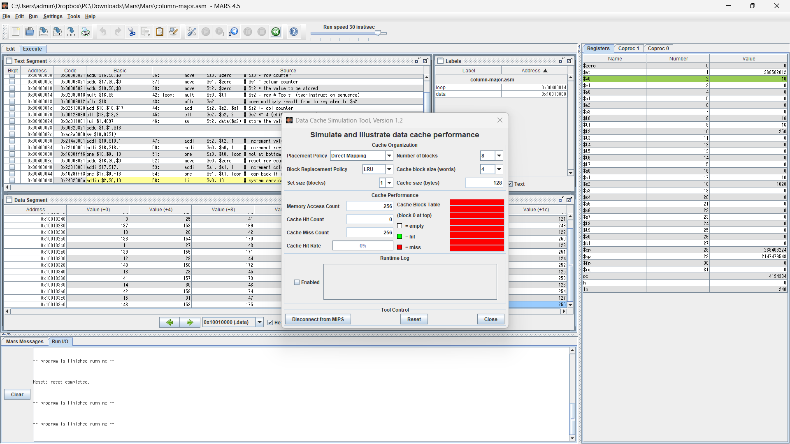
- The final cache hit rate was 0%
- The hit rate will be 0% if the block size is increased from 4 words to 8 words and 0% if the block size is decreased from 4 words to 2 words.
- Verify:
  - Increased from 4 words to 8 words:
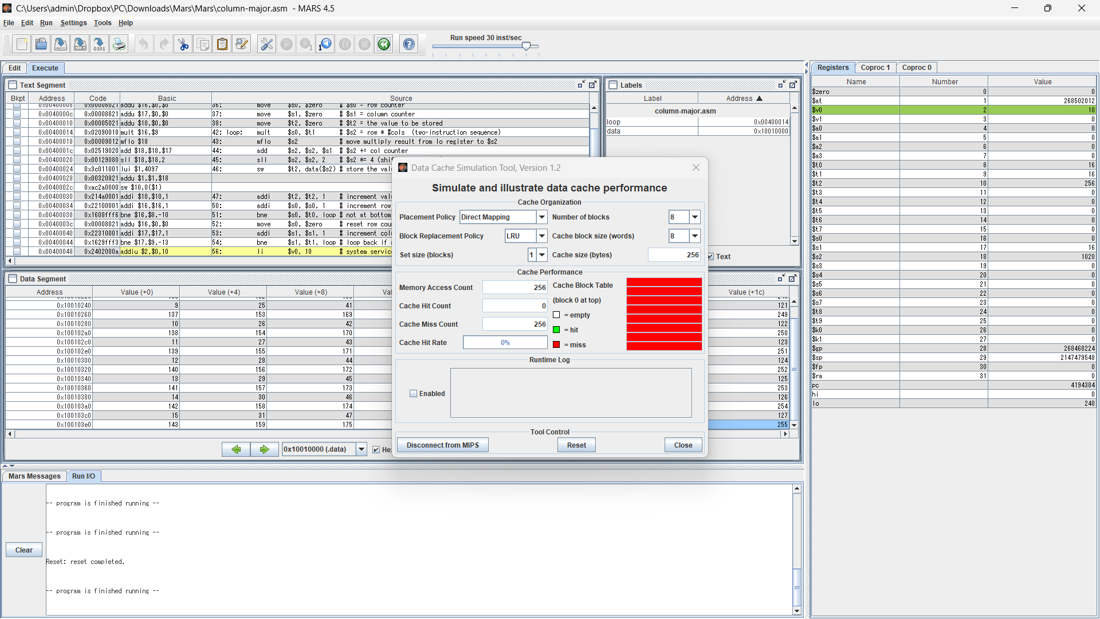
  - Decreased from 4 words to 2 words:
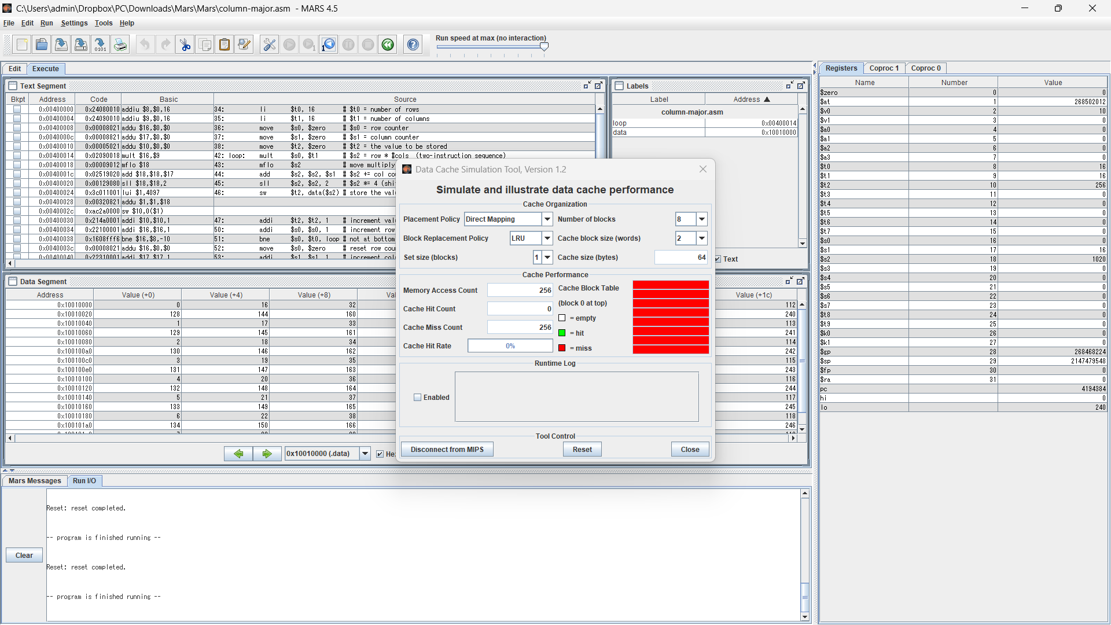
12. The cache performance for this program was 0%.
14.
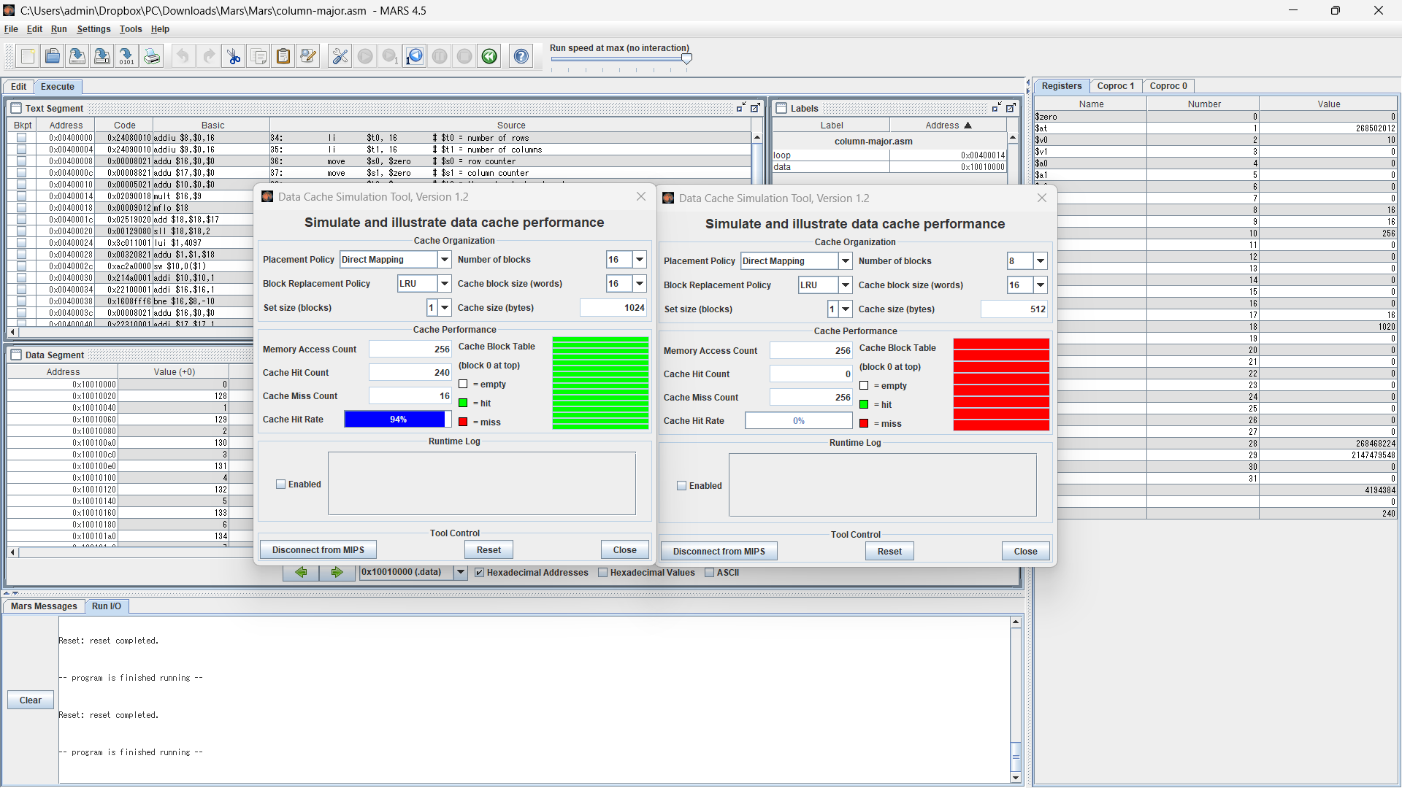
15.
- The cache performance of the original tool instance is 0%.
- The cache performance of the second tool instance is 94%.

Assignment 2: The Memory Reference Visualization tool
7.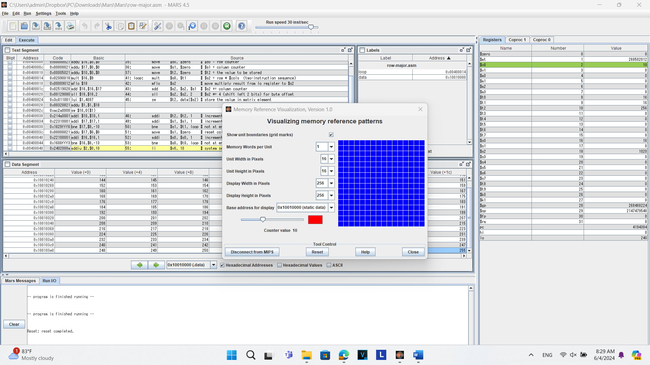8.
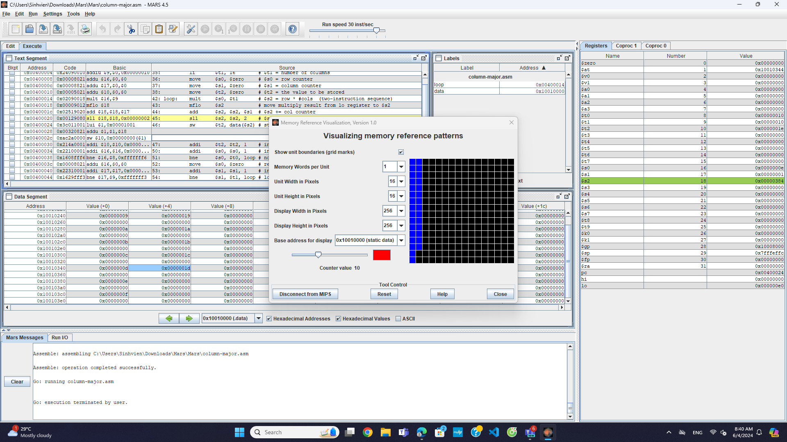9.
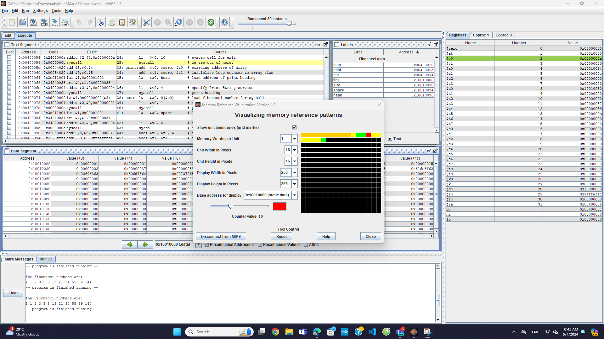10.
